Smart AI Platform for Multilingual Legal Document Classification, Summarization and Retrieval
A
Synopsis
Submitted partial fulfillment of the requirement for the
award of degree of

BACHELOR OF TECHNOLOGY
In

Department of Artificial Intelligence & Data Science
Submitted to


ANJUMAN COLLEGE OF ENGINEERING

& TECHNOLOGY
Submitted by
Laiba Khan(07) Munira Firdos(10)
Adiba Sheikh(17) Alkaif Pathan(28)
Arsalan Khan(35) Sanobar Khan(58)
Under the guidance of
Dr. Syed Irfan Ali

Assistant Professor

Department of Artificial Intelligence & Data Science

RASHTRASANT TUKDOJI MAHARAJ NAGPUR UNIVERSITY

NAGPUR, MAHARASHTRA

2026-2027

Abstract

Smart AI Platform for Multilingual Legal Document Classification, Summarization and Retrieval is an innovative AI-based platform that focuses on solving the backlog of legal cases by providing automated processing of complicated, voluminous legal documents. In this particular application, the user is able to upload a legal document in multiple Indian languages. The system automatically recognizes the class to which the document belongs, summarizes the main points and enables fast information retrieval from the entire legal database. The application makes use of transformer-based deep learning algorithms trained on legal data combined with multilingual models allowing for seamless transition between different Indian languages, enabling the identification, extraction, summarization, and retrieval functions. The live search and retrieval feature allows the user to search for legal information in natural language and obtain the relevant results, documents, or judgments without sifting through hundreds of pages of information. The intended purpose of the innovation is to reduce the time and effort spent on legal document reading and research, thus, reducing inconsistencies and accelerating the resolution process for better management of the overflowing docket in India's judicial system.

Keywords: Legal Document Classification, Text Summarization, Multilingual NLP, Information Retrieval, Transformer-based Models, Legal Document Intelligence.
Contents

Chapter  No. | Name of Chapter | Page  No.
1 | Introduction | 1
2 | Literature Review | 2-4
3 | Problem Statement | 5
4 | Aim & Objective | 5
5 | Proposed System | 6-7
6 | Advantages of Proposed System | 8
7 | Applications | 9
8 | System Requirement | 10
9 | Future Scope | 11
10 | Conclusion | 12
11 | References | 13

Introduction

India's judicial system faces a significant challenge with over 5 crore pending cases, largely due to the time-consuming manual processing of legal documents. These documents are often lengthy, complex, and available in multiple Indian languages, making classification, analysis, and retrieval difficult and inconsistent. Although Artificial Intelligence (AI) and Natural Language Processing (NLP) have improved legal document analysis in English-based judicial systems, India still lacks a scalable multilingual platform capable of handling legal documents across different regional languages.
This project proposes a Smart AI Platform for Multilingual Legal Document Classification, Summarization, and Retrieval to automate three essential legal document processing tasks: classifying documents by case type or legal provisions, generating concise summaries of lengthy judgments, and retrieving relevant legal information using natural-language queries. Unlike existing legal AI solutions that focus on a single language or a specific task, the proposed platform integrates all three functionalities within a unified multilingual system tailored to the Indian legal domain.
The proposed methodology begins with a comprehensive review of existing legal NLP research, focusing on transformer-based models such as BERT, DeBERTa, and GPT architectures used for legal classification, summarization, and retrieval. The review highlights a common limitation in current systems: the absence of integrated multilingual support for Indian legal documents. Based on these findings, the project designs a framework that combines multilingual transformer embeddings with dedicated modules for classification, summarization, and intelligent document retrieval.
The expected outcome is a functional prototype capable of accurately processing multilingual Indian legal documents, producing meaningful summaries, and retrieving relevant legal information efficiently. By providing an integrated AI-driven solution, the project aims to reduce the manual workload of legal professionals, improve access to legal information, and contribute to a more efficient judicial process in India.

Literature Review
A comprehensive literature review was conducted on six recent research papers related to Artificial Intelligence (AI), Natural Language Processing (NLP), Large Language Models (LLMs), Retrieval-Augmented Generation (RAG), and Legal Document Processing. The reviewed studies explored various Legal NLP tasks, including legal document classification, summarization, semantic retrieval, legal question answering, legal judgment prediction, and AI-assisted legal consultation. Several papers proposed transformer-based architectures, Retrieval-Augmented Generation frameworks, graph-based summarization techniques, and systematic reviews of Legal NLP methods to improve the efficiency and accuracy of legal document analysis.

The literature indicates that significant progress has been made in developing AI-based legal systems; however, most existing research focuses on single tasks such as question answering, judgment classification, contract analysis, or legal consultation and is primarily developed for English or other foreign legal systems. Common research gaps identified include the limited availability of multilingual legal datasets, lack of support for Indian legal documents, absence of integrated platforms combining classification, summarization, and semantic retrieval, and challenges related to scalability, explainability, and real-world deployment. These findings establish the need for a comprehensive AI-powered legal document intelligence platform.

Based on the identified research gaps, the proposed system aims to develop a Smart AI Platform for Multilingual Legal Document Classification, Summarization and Retrieval specifically for the Indian judicial system. The proposed platform integrates multiple Legal NLP functionalities—including automated document classification, AI-based summarization, semantic retrieval, and multilingual legal document processing—within a unified framework to reduce manual effort, improve legal research efficiency, and support faster access to relevant legal information.

Research Paper | Methodology | Research Gap
- “Reducing Hallucinations in Legal AI: A Retrieval-Augmented Generation Based Model for Accurate Legal Guidance” | Legal PDF documents are converted to Markdown, cleaned, segmented into chunks, and transformed into vector embeddings.  Vector similarity search retrieves relevant legal passages, which are supplied as context to Llama-3.2-3B-Instruct and Qwen2.5-3B-Instruct through RAG.  The system is evaluated using ROUGE, BLEU, MPNet Similarity, BERTScore F1, and MRR across different embedding–LLM combinations. | The study focuses primarily on legal question answering, not automated legal document classification and summarization.  The proof-of-concept uses a relatively small dataset, limiting its validation for large-scale legal document repositories.  Multilingual legal processing, multimodal inputs, case law/contracts, and faster retrieval mechanisms remain areas for future research.
- “Efficient and Fair Legal Judgment Classification via Personalized GraphRank Summarization and Class-Balanced Learning” | Personalized GraphRank (PGR) performs extractive summarization using TF-IDF, Personalized PageRank, and MMR to select relevant and non-redundant sentences.  The generated summaries are classified using the DeBERTa-v3-base transformer for multi-label legal judgment classification.  Class-weighted Binary Cross-Entropy and label-specific threshold calibration are used to address class imbalance, using the ECTHR/A dataset from LexGLUE. | The study focuses on European legal judgments and does not address the Indian legal environment.  It does not support multilingual/cross-lingual retrieval, particularly across Indian languages.  It does not provide an integrated platform combining classification, summarization, retrieval, and large-scale legal document management.
- “Legal Natural Language Processing from 2015–2022: A Comprehensive Systematic Mapping Study of Advances and Applications” | A Systematic Mapping Study (SMS) screened 536 papers and analyzed 75 primary studies from major academic databases.  The research maps Legal NLP techniques across classification, summarization, information retrieval, information extraction, QA, and cross-lingual transfer.  It reviews approaches ranging from SVM/Naive Bayes and deep learning models to BERT, Legal-BERT, Lawformer, T5, GPT, and other transformer-based models. | Existing Legal NLP research is predominantly English- and Chinese-focused, with very limited multilingual/cross-lingual research.  There is a lack of publicly available datasets for low-resource languages, including Indian languages.  There is an absence of integrated systems combining classification, summarization, and information retrieval into one platform.
- “Exploring LLMs Applications in Law: A Literature Review on Current Legal NLP Approaches” | The study follows a Systematic Literature Review (SLR) methodology based on PRISMA guidelines.  Studies were systematically searched, screened, assessed using quality criteria, and 61 research papers were selected for detailed analysis.  The reviewed approaches include LLMs, Transformer models, legal-domain models, multilingual models, information retrieval techniques, classification, summarization, and legal QA. | Multilingual legal document processing, especially for low-resource languages such as Indian languages, remains underexplored.  Challenges remain in processing long legal documents and the availability of sufficiently large annotated legal datasets.  Explainability, reliability, ethical issues, and real-world deployment of LLM-based legal systems remain unresolved.
- “CHRExpert: An AI-Driven Court of Human Rights Expert Assistant for Legal Practitioners Utilizing Transformer Models” | Approximately 11,000 ECHR judgments are preprocessed, cleaned, tokenized using Byte Pair Encoding (BPE), and divided into training, validation, and testing sets.  A GPT-J transformer is fine-tuned using transfer learning with token embeddings, multi-head attention, FFN, Adam optimization, and cross-entropy loss.  The system performs legal issue spotting, document classification, statutory interpretation, precedent comparison, and judicial outcome prediction. | The system is trained primarily on European Court of Human Rights cases, limiting applicability to the Indian legal ecosystem.  It lacks multilingual Indian legal document processing and does not integrate classification, summarization, and semantic retrieval in one platform.  Its effectiveness is affected by historical precedent dependence, judicial discretion, dataset bias, and limited cross-jurisdictional generalizability.
- “SmartLaw Advisor: AI-Powered Legal Consultation and Contract Analysis for Saudi Arabia” | Saudi legal documents and contract resources are collected, cleaned, segmented into semantic chunks, and converted into vector embeddings stored in ChromaDB.  Semantic retrieval and cross-encoder re-ranking identify relevant legal context before sending it to Google Gemini 1.5 Flash through a RAG pipeline.  OCR and multilingual document processing are incorporated to extract information from scanned Arabic/English legal documents and contracts. | The system is designed specifically around Saudi Arabian law, leaving a gap for legal AI adapted to the Indian legal framework.  There is limited availability of Arabic legal retrieval datasets and benchmarks; similarly, Indian legal AI requires domain-specific multilingual datasets and benchmarks.  The system focuses on legal consultation and contract analysis, rather than an integrated platform for multilingual classification, summarization, and retrieval of diverse Indian legal documents.

Problem Statement
India's legal system faces a significant backlog of over 5 crore pending cases. A major contributor is the manual effort required to process complex, voluminous legal documents in multiple languages. Currently, no scalable AI platform exists that can classify and summarize legal documents in a multilingual Indian context. There is an urgent need for a domain-specific, AI-enabled legal document intelligence platform that can automate classification, summarization, and facilitate efficient information retrieval from legal documents.

Aim & Objective
To develop a Smart AI Platform for multilingual legal document classification, summarization, and retrieval. The platform reduces manual effort by making legal documents easier to organize, understand, search, and retrieve.

- To develop a multilingual AI model for automatic classification of Indian legal documents such as civil, criminal, taxation, etc.
- To build a legal judgment summarizer to condense lengthy court documents into short, structured summaries.
- To design an intelligent legal search interface that provides query-based access to relevant legal documents.
- To evaluate the proposed AI system with legal professionals to assess its practical usefulness and real-world impact.

Proposed System
The proposed system, "Smart AI Platform for Multilingual Legal Documents Classification Summarization and retrieval" is a domain-specific AI platform designed to automate the processing of multilingual legal documents in the Indian judicial system. The system collects legal documents such as judgments, FIRs, petitions, acts, contracts, and court orders, preprocesses them into structured text, and applies Natural Language Processing (NLP) techniques to classify documents, extract key legal information, generate concise summaries, and organize the processed information within a centralized legal knowledge repository. It further enables semantic retrieval of relevant legal documents through an interactive interface, allowing users to efficiently access legal information. By integrating classification, summarization, and intelligent retrieval into a single platform, the proposed system aims to reduce manual effort, improve legal research efficiency, and support faster, more informed decision-making in the Indian legal ecosystem.

Modules of the Proposed System
1. Documents (Input Layer): Collects legal documents from various sources.
2. Data Preprocessing: Converts raw legal documents into clean, structured, and machine-readable text.
3. AI Processing Engine: Analyzes legal documents using AI to extract meaningful legal information.
4. Legal Knowledge Repository: Organizes and stores processed legal knowledge in a centralized repository.
5. Semantic Retrieval: Retrieves the most relevant legal documents using semantic understanding.
6.Document Intelligence: Generates document classification, summarization, and legal insights.
7. Legal Intelligence Portal: Provides an interactive platform for searching and accessing legal information.
8. End Users: Enables judges, lawyers and researchers to utilize the system effectively.
9. Expected Outcomes: Improves legal document processing efficiency and supports faster decision-making.

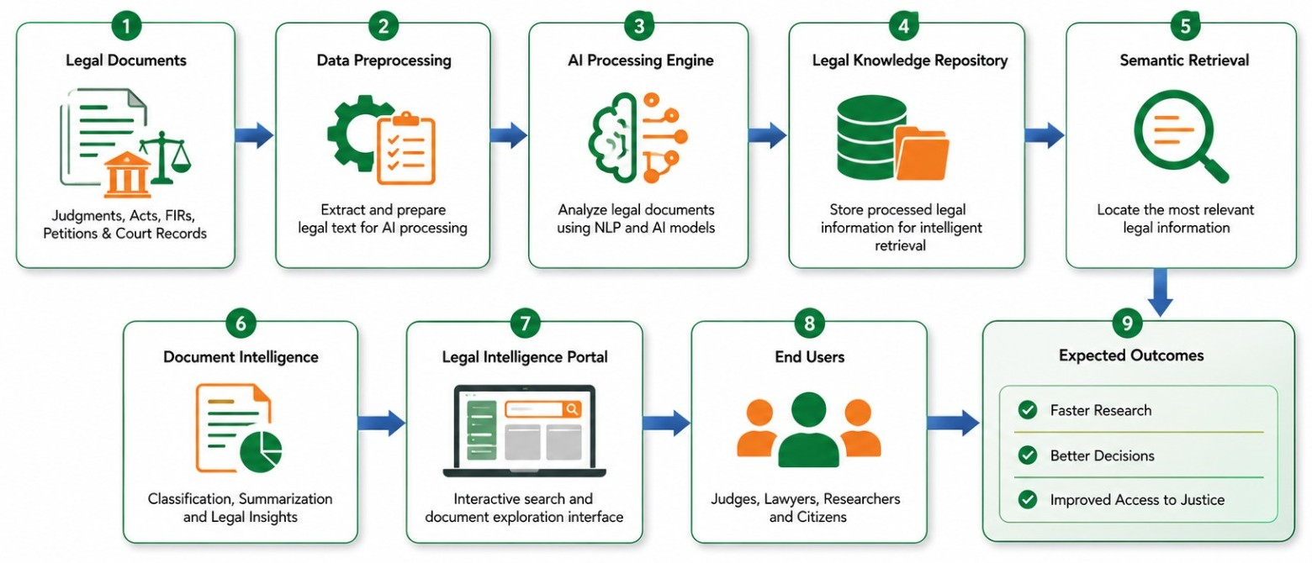

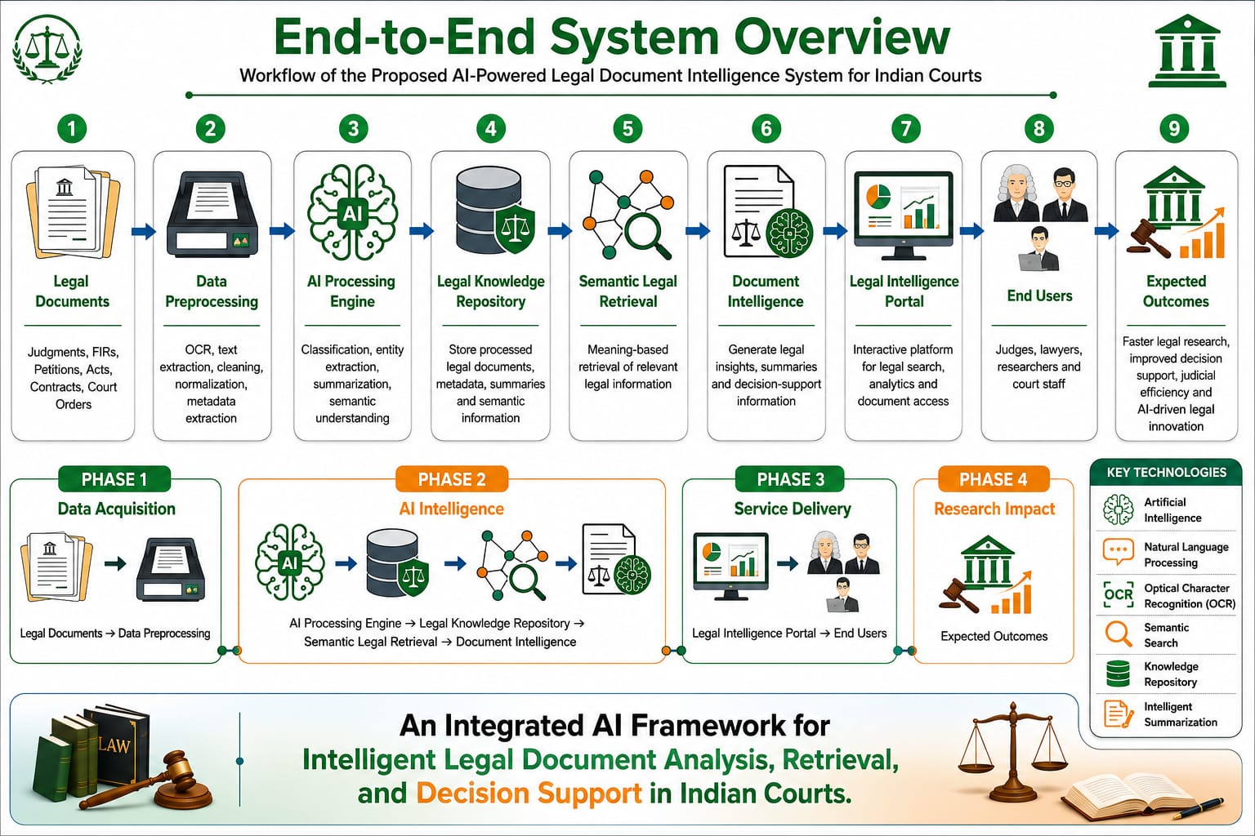

Advantages of the Proposed System
- Reduces Manual Effort: The system automates the classification and summarization of legal documents, reducing the need for lawyers and legal professionals to manually read and analyze large volumes of lengthy documents.
- Supports Multiple Indian Languages: The proposed platform is designed to process legal documents in multiple Indian languages, making legal information more accessible and useful in India's multilingual legal environment.
- Saves Time in Understanding Legal Documents: Lengthy judgments and legal documents can be difficult and time-consuming to read. The summarization module provides concise and structured summaries, helping users understand important information more quickly.
- Efficient Legal Document Retrieval: Intelligent search functionality enables users to search for relevant legal documents using queries instead of manually going through a large collection of files. This can help legal professionals locate useful judgments and documents more efficiently.
- Improves Accessibility of Legal Information: By combining multilingual processing, classification, summarization, and retrieval in one platform, the system makes relevant legal information easier to access and understand for lawyers, researchers, and other legal professionals.
- Handles Large Volumes of Legal Documents: The proposed AI-based approach can assist in processing a large collection of legal documents more efficiently than completely manual methods, making it suitable for environments where legal records are continuously generated and stored.
- Provides an Integrated Legal Document Platform: Instead of performing classification, summarization, and document searching separately, the proposed system brings these capabilities together on a single platform. This provides a more convenient workflow for users and helps them move from finding a document, understanding its contents, and accessing relevant information efficiently.

Applications
- Law Firms and Legal Practitioners: The system can be used by lawyers and law firms to process large collections of legal documents and judgments. Lawyers can use classification to identify the type of legal document, summarization to quickly understand lengthy judgments, and intelligent search to find relevant documents for their cases.
- Courts and Judicial Institutions: Judicial institutions handle a large number of legal records and judgments. The proposed system can assist in classifying and summarizing these documents, making it easier to locate relevant information and reduce the time spent on manually reviewing large document collections.
- Government Legal Departments: Government departments regularly deal with laws, regulations, court judgments, petitions, and other legal records. The multilingual capability of the system can help departments process documents available in different Indian languages and retrieve relevant information more efficiently.
- Legal Research and Case Preparation: Lawyers and legal researchers can use the platform while preparing cases and conducting legal research. Instead of manually reviewing numerous lengthy judgments, users can search for relevant documents and use generated summaries to identify useful information for further analysis.
- Legal Education and Academic Research: Law students, teachers, and academic researchers can use the system to study judgments, legal documents, and different areas of law. Summarized documents can help students understand lengthy cases more easily, while intelligent retrieval can help researchers locate relevant legal material for their studies.
- Multilingual Legal Document Management: The system can be applied in organizations that handle legal documents in multiple Indian languages. It can help process, classify, summarize, and retrieve documents across different languages, making it particularly useful where legal information is not available only in English.

System Requirements
Hardware:
- Processer: Ryzen 5/ intel i5
- RAM: 8 GB or higher
- Storage: 256 GB SSD or higher
- Graphics: NVIDIA GPU
Software:
- Core Language: Python, JavaScript
- Technology: Artificial Intelligence (AI), Machine Learning (ML), Natural Language Processing (NLP), Large Language Model (LLM), Retrieval-Augmented Generation (RAG), Optical Character Recognition (OCR)
- Framework: FastAPI, React.js, LangChain, Hugging Face Transformers
- API: Google Gemini API, IndicTrans2 API, Tesseract OCR API
- Deployment: Docker, AWS EC2
- Database (Vector): Qdrant
- Datasets: Indian Court Judgments Dataset, Indian Kanoon Public Judgments, eCourts Judgments, AI4Bharat IndicCorp, Legal Document Corpus (FIRs, Petitions, Judgments, Affidavits, Bail Orders)
- Web Technologies: HTML5, CSS3, JavaScript, React.js, Tailwind CSS
- Backend Technologies: FastAPI, LangChain, LLM Integration, RAG Pipeline, REST API, JWT Authentication

Future Scope
The proposed AI-powered legal document intelligence system can be further enhanced in the following areas:

1.Expansion to More Languages: The system can be extended to support a wider range of languages and cross-lingual legal document retrieval, enabling users to access relevant legal information irrespective of the document language.
2. Large-Scale Legal Document Processing: The platform can be scaled to handle larger collections of judgments, petitions, FIRs, acts, orders, contracts and other legal records from different levels of the Indian judiciary.
3. Advanced Legal Document Understanding: Future versions can incorporate improved legal-domain models for better understanding of complex legal terminology, relationships between cases, statutes, sections and legal entities.
4. Improved OCR and Multimodal Processing: The system can be extended to handle poor-quality scanned documents, handwritten documents, tables and other non-textual information commonly present in legal records.
5. Explainable and Trustworthy Legal AI: Future development can focus on providing stronger explainability through source citations, supporting legal passages, confidence indicators and traceable evidence for AI-generated outputs.
6. Continuous Model Improvement: The system can incorporate human feedback and newly available legal documents to continuously improve classification, summarization and retrieval performance while maintaining appropriate validation and quality control.
7. Integration with Legal Workflows: The platform can be further developed to integrate with existing digital court repositories and legal information systems, providing a unified environment for document management, research and legal information access.

Conclusion

The proposed Smart AI Platform for Multilingual Legal Document Classification, Summarization and Retrieval aim to reduce the time and manual effort required to process large volumes of legal documents. By combining multilingual document processing, automatic classification, legal document summarization, and intelligent retrieval in a single platform, the system can help legal professionals find and understand relevant legal information more efficiently. The proposed system is particularly useful in the Indian legal context, where legal documents may be available in different languages and can be lengthy and complex. Overall, the project aims to provide a practical and efficient AI-based solution for improving accessibility, understanding, and retrieval of multilingual legal information.
References
[1] S. Gupta, V. Agrawal, Y. Negi, S. Karunanithi, and A. Balakrishnan, "Reducing Hallucinations in Legal AI: A Retrieval-Augmented Generation-Based Model for Accurate Legal Guidance," IEEE Access, vol. 14, pp. 44451–44463, Mar. 2026, doi: 10.1109/ACCESS.2026.3675624

[2] K. S. Rosamma, N. Patil, and C. D. Jaidhar, "Efficient and Fair Legal Judgment Classification via Personalized GraphRank Summarization and Class-Balanced Learning," IEEE Access, vol. 14, pp. 104077–104089, 2026, doi: 10.1109/ACCESS.2026.3708100

[3] E. Quevedo, T. Cerny, A. Rodriguez, P. Rivas, J. Yero, K. Sookasatra, A. Zhakubayev, and D. Taibi, "Legal Natural Language Processing from 2015-2022: A Comprehensive Systematic Mapping Study of Advances and Applications," IEEE Access, vol. 11, Art. no. 3333946, 2023, doi: 10.1109/ACCESS.2023.3333946

[4] M. Siino, M. Falco, D. Croce, and P. Rosso, “Exploring LLMs Applications in Law: A Literature Review on Current Legal NLP Approaches,” IEEE Access, vol. 13, pp. 18253–18276, Jan. 2025, doi: 10.1109/ACCESS.2025.3533217

[5] Y. Al-Shareef, "CHRExpert: An AI-Driven Court of Human Rights Expert Assistant for Legal Practitioners Utilizing Transformer Models," IEEE Access, vol. 13, pp. 41097–41110, 2025, doi: 10.1109/ACCESS.2025.3547763

[6] F. Almutairy, S. Almutairi, M. Abdullah, and S. Salman, “SmartLaw Advisor: AI-Powered Legal Consultation and Contract Analysis for Saudi Arabia,” IEEE Access, vol. 14, pp. 32638–32653, Mar. 2026, doi: 10.1109/ACCESS.2026.3524673

